[GENDER AT SCHOOL AND SOCIETY](https://bidyapatibedstudy.com/sell-ebooks-online/)

# [Opinion of Author](https://bidyapatibedstudy.com/sell-ebooks-online/)

[*The purpose of this article is to analyze the role of gender in society in interdisciplinary and*](https://bidyapatibedstudy.com/sell-ebooks-online/)[*intersectional gender studies perspectives. In the article I discuss theories and the role of*](https://bidyapatibedstudy.com/sell-ebooks-online/)[*gender in social development. It is my belief that gender is an important factor in social*](https://bidyapatibedstudy.com/sell-ebooks-online/)[*development. There are specific structures that can impact on the lives of different groups of*](https://bidyapatibedstudy.com/sell-ebooks-online/)[*people. Around the world, more women than men are in poverty, and they are less likely than*](https://bidyapatibedstudy.com/sell-ebooks-online/)[*men to receive basic education and be appointed to a political position both nationally and*](https://bidyapatibedstudy.com/sell-ebooks-online/)[*internationally. Each experience of poverty can be different from other people’s, and they*](https://bidyapatibedstudy.com/sell-ebooks-online/)[*can face different barriers to obtain services. It is important to review gender - related issues*](https://bidyapatibedstudy.com/sell-ebooks-online/)[*and the theories and concepts of feminist, critical race and gender studies. The article*](https://bidyapatibedstudy.com/sell-ebooks-online/)[*includes classic works and theoretical perspectives on gender and education.*](https://bidyapatibedstudy.com/sell-ebooks-online/)

# [Introduction](https://bidyapatibedstudy.com/sell-ebooks-online/)

[Every child is unique and this uniqueness of the individual is one of the greatest fundamental](https://bidyapatibedstudy.com/sell-ebooks-online/) [characteristics of their life. Even children from the same family, differ one another, and their](https://bidyapatibedstudy.com/sell-ebooks-online/) [equality is the most dominant concern of modern times because it refers to equivalent](https://bidyapatibedstudy.com/sell-ebooks-online/) [qualifications for social standards for equivalent abilities and also capabilities as fundamental](https://bidyapatibedstudy.com/sell-ebooks-online/) [for the same rights and the same opportunities for learning and working. Gender roles are](https://bidyapatibedstudy.com/sell-ebooks-online/) [sometimes created on the basis of stereotypes about gender based on the human mind. These](https://bidyapatibedstudy.com/sell-ebooks-online/) [gender stereotypes oversimplified understandings of males and females and the differences](https://bidyapatibedstudy.com/sell-ebooks-online/) [between them. These individuals are created by bias, sometimes by their perceptions about](https://bidyapatibedstudy.com/sell-ebooks-online/) [gender roles. However, differences in personality make-up of these individuals bring about](https://bidyapatibedstudy.com/sell-ebooks-online/) [differences in intellectual pursuits and achievement. Because of diversity in interests and](https://bidyapatibedstudy.com/sell-ebooks-online/) [goals of the social and their habits, background, mental abilities their gender opportunity also](https://bidyapatibedstudy.com/sell-ebooks-online/) [make different with them.](https://bidyapatibedstudy.com/sell-ebooks-online/)

[Some effective teachers in the classroom, teaching and give examples for gender differences](https://bidyapatibedstudy.com/sell-ebooks-online/) [and they use teaching as strategies which are not biased against girl students or lower social.](https://bidyapatibedstudy.com/sell-ebooks-online/) [Such teachers created and give better opportunity for those children and they prepared that](https://bidyapatibedstudy.com/sell-ebooks-online/)

girls should not have a different type of education which may not helpful for them to develop better social responsibility. To implement gender equality, education policy planners have to make major changes that need to be brought about in the learning content being taught in schools. However, there are certain NGOs that are working towards the equal social rights goal and implementing gender equality based content in curriculums, by teaming up with schools. These gender issues are performing within society because of lack of knowledge, awareness and acceptance of the reality of girls and women, but their different needs and competences, leads to sex stereotyping and other hidden forms of discrimination.

# Discrimination of gender in classrooms and school

Gender discrimination in education exists very well in some sections of society, and even in the institution of differential treatment students receive by either male or female teachers. Perceptions of teachers are made to students, and it can influence discrimination. This discrimination against male students will often happen. But sex discrimination in many parts of society applies a larger social factor to females in several ways. These differences in the socialization of girls and boys start with the type of toys which they have to choose.

This alone makes the subtle lessons in the classroom learning and that makes them minds to continue with conditioning. These gender differences messages are all around us, but the best educational learning environments make awareness of those that are fair to all students, male or female. Because of this awareness, teachers play a pivotal role in promoting gender disparity in classroom learning. There are gender biases in the classroom which affect everything, from personal confidence, test results to professional choices.

Generally, gender is typically seen as binary male and female, while individuals who identify themselves as non-binary a term to describe genders that don't fall into one of these two categories. However, it is crucial to understand the relationship between gender inequality and the lack of educational opportunities. As more children become not aware of gender stereotypes, it is likely to be harder to make a good student because any child's development in educational areas can also be influenced by the way treatment with child which is receives, even from their parents as well.

Parents may have different perceptions of their kids based on the gender, and unjust treatment of them. Teachers and students must be proactive to support an equal and stereotype-free

environment in the classroom and both the teacher and the classroom should be responsible for equal opportunities for all students. Students have different emotions to understand the relationship between gender inequality and about taking part, but a strong teacher can try to encourage them to participate in awareness. The demand for educational opportunities has also increased due to the fact that schools do have main responsibilities of gender stereotypes.

# Differences between gender and sex

When we talk of gender differences, it is intended to talk about characteristics of an individual in terms of which have various differences. Gender and sex are different concepts in the social base factors and gender refers to the meanings, values, and characteristics that people ascribe to different sexes. In short, gender refers to the society, and has learned their attitudes and behaviors that are associated with being male or female. Sex is a completely different factor, and it refers to the biological characteristics with which they were born that determine whether a person is male or female.

It includes anatomical differences and differences in sex chromosomes, hormones and physiology in the individual. The distinction between gender and sex it differentiates sex from gender, which it refers to either social roles, it is purely based on the sex of the person. However, in some circumstances, an individual's assigned sex and gender do not align, and the person may be transgender, gender-nonconforming, non-binary, or intersex.

|  |  |
| --- | --- |
| **Gender** | **Sex** |
| Gender is socially constructed have specific  roles, responsibilities and behaviour patterns | Sex is biological, and it is noticeable  differences in reproductive organs. |
| The role of gender is culturally specific. | Sex is natural, it is constant and Universal. |
| It varies within and between in society for  example as per regulations of social institutions. | Sex cannot be changed. |

In a lot of cases, the terms sex and gender are used interchangeably but two separate concepts even though there is a difference in the definitions that are shared by people who are the same sex and gender. The gender distinction between men and women is not universal. In most

common conversations, gender and sex are interchangeably used. They are given different definitions by dictionaries and academic disciplines.

The socially learned behaviors associated with being male or female are called gender. The only roles related to sex are those associated with reproduction, and males and females contribute to the transfer of genetic material. Basically, almost all people are born with physical characteristics that are labeled male or female. Having two genders is a social construction that relates to behaviors and attributes based on labels of masculinity and femininity. In the end, it is common for individuals to identify with a specific gender based on sex. There are variations in sex characteristics that are natural. Sex is not gender, but we still treat them as the same and they are used interchangeably.

# Gender and Education

In many countries, gender equality has not yet reached full support by society, and even in education, girls and women are discriminated against men in their access, permanence, completion, treatment, learning outcomes and career choices. In education, there are often views as gender differences in education. These social behaviors impact on education and there are still a lot of hurdles to getting pregnant and a lack of information about the right person, and at this age. There are also a lot of challenges to gender equality in education. These characteristics that distinguish between masculinity and femininity in their education and these characteristics may include social and biological sex in the context of what education they need to learn. However, education has become a key factor in the individual's life, but before a child starts school, there is a noticeable inequality between boys and girls.

Although, society must know that classrooms are microcosms of society, and they mirror, its creation strengths and even ills alike, they follow better normal socialization patterns than young children that often lead to distorted perceptions of gender roles are reflected in the classrooms. In every sphere of life, especially education, equity is a key to gender equality. Gender is a concept that humans create socially, through their interactions with one another and their environments, yet it relies heavily on biological differences between males and females. There are many times when a person can feel a difference between a person and a person. Getting gender equality will improve the environment, including improving the quality of life.

# Gender roles in society

The roles of gender are based on different expectations. Individuals, groups, and societies have based on their sex and based on each society's created values and beliefs about gender role and expectations. However, these gender roles are the product of the interactions between individuals and their environments, and they also give individuals cues about what sort of behavior is believed to be appropriate for what sex.

This sex appropriate gender roles are defined according to a society's beliefs about differences. They were referred to socially, and asked them to learned attitudes and behaviors which are associated with being male or female. This role is based on behavior expected of someone who holds a particular status socially. Here the key word is social expected. This role consists of the expectations that are defined for a particular person in a particular situation in a particular culture for society.

This society expects how they’re expecting to act, speak, dress, groom, and conduct themselves were based upon their assigned sex. This gender is a structural way to create environmental constraints and opportunities that usually benefit men or women. It is more likely for people with nontraditional gender roles to think that a person's behavior should not be determined solely by their sex. People with gender roles are more likely to believe in egalitarian relationships between men and women and their role in their personal decisions. In the social context, the concept of gender was first created by human beings.

The social constructions on gender are not only shared but also socially. The social construction of gender is demonstrated by individuals and societies ascribe traits and values to individuals purely because of their sex, yet these ascriptions differ across societies and cultures, and over time within the same society.

# Gender and Caste

Caste and ethnic biases are the most common social issues that are with us in our everyday lives. These biases are not something that suddenly comes into our beliefs and thoughts, but our past has a dwelt and developed character over time. In all social spheres of life, men enjoy the dominance of women over women. It is common practice in many countries to subordinate women, and they are much more socially responsible than people else. Subordination of women is a universal phenomenon, but one must remember it. The extent

and nature of subordination of women are determined by their social, economic and cultural environment. Their gender issue is, thus, not a monolithic category, and they are in-numbers of social spheres for them. The Caste is a group of people who determine their membership by birth. Each caste has an attributed category; therefore each caste has its own traditional occupation.

In the past, women were conceptualized differently. Women were generally portrayed as having a sinful nature. There was wickedness and guile in the sex of women. There are many ways in which prejudice is learned. Prejudice is not something you are born with; it is something that you learn. Whether we realize it or not, prejudice leads to violence between different communities. Hundreds of millions of people are still involved in caste, though it has changed significantly since independence. The Indian constitution prohibits caste-based negative public discrimination. Despite this, caste rankings and caste-based interactions have existed for centuries and will continue to do so well into the foreseeable future, more in rural areas than in urban areas and more in the realms of kinship and marriage than in less personal interactions.

# Nature of Gender Issues

Equal rights for women and men are fundamental human rights, a cornerstone of democracy, and it is a fundamental principle of social justice. There are still inequities between women and men in present day societies, including in the areas of education, politics, economics, societal, and cultural affairs. In education, women and men's equality should be emphasized as a natural human right. It is an issue when a teacher differentiates the learning experience in a manner that limits the chances for girls and boys in the classroom.

In each gender issue or gender-related issue, educationally relevant processes and skills are addressed. There was differential treatment of boys and girls in the same classrooms, with the same teacher, who experienced the same curriculum. However, all educators must be prepared each child education has a very fundamental role to play in this work, and human rights can only be taught in schools with a democratic ethos.

To achieve this, classroom learning must be gender balanced and cross-cultural, respecting the diversity of cultures. Education still heavily reinforces gender stereotypes in society, which reinforces unequal gender power relationships, the sex-segregation of the labor market,

and gender-specific family responsibilities to both sexes as regards education, occupations, and lifestyles. The achievement of gender equality and cross-cultural equality in education should be seen as difficult goals. A series of measures are proposed in the fields of education, legislation, information, research and international cooperation. Gender equality in education is an important part of making the system more egalitarian. Gender is not a matter of gender for women, but of people.

# Implications for Teachers

Teachers are important beginning points for promoting gender equality in education. To promote girls and boys equally in coeducational settings, teachers have to reflect on their own gender stereotypes. Children in society learn at a very young age that there are differences between boys and girls, because educators play a very important role in the early upbringing of a child socially believed.

Their ideas and beliefs can change thought, effective guiding processes. Classrooms are major contexts for gender socialization, in part because children spend large amounts of time engaged with peers in such settings. However, dealing with gender issues with a cast that is different is not simple. Education is universally acknowledged to benefit these individuals, beliefs and promote social development. Educating children for social benefit produces future opportunities and choices.

However, educating girl’s child has added socio-economic advantages to entire societies. Gender stereotypes are rarely dealt with in general teacher education, and training programs that build teachers’ competence for reflective education are sparse. To motivate all students regardless of gender, they must have knowledge about gender differences in education. These differentiations are made visible to students by teachers as well as peers. Teachers must provide their students with different learning opportunities.

Teachers have a tendency to go against gender stereotypes, as well as peers are able to teach them; because a child does not recognize gender stereotypes and prejudices, they may use them to guide their own preferences and behaviors. Many educators hold cultural gender stereotypes that shape their classroom behavior in at least one way of teaching-learning. Parents and teachers should educate their children on the differences between genders.

School plays an important role in instilling sensitivity in students' etiquette and manners. They need to take into consideration what they are in need of.

# Development challenge

There are many biological and physical characteristics to being a man or a woman. A difference between men and women is between what they should dress for and what their expectations are about working. Implementing a gender equality plan often challenges many of the steps that need to be taken because inequality between men and women is more than a moral and social problem. Some people mistakenly state that a gender equality approach is not an ideology. Having unhealthy relationships should be encouraged.

The gender structure is constructed by creating opportunities and limitations which benefit men more than women. The inequalities related to the ability of women and girls to live healthy, active lives are a strong equity case. Gender equality is essential to the right to quality education. The Citizen Movement has launched a campaign to break myths, lies, and fears about the importance of gender equality.

The idea is to promote pedagogical tools that redefine gender perspectives towards a non- sexist education. Achieving gender equality results in changes for both men and women. We must not forget gender as one of the most important factors in men's social identity. There are gender gaps in human capital that need to be addressed. It is believed that children are assigned a gender from birth and are socialized to conform to certain gender roles based on their biological sex.

We must see the rich diversity of genders in the continuum of view. Almost all Western societies operate on the idea that gender is a binary, meaning that no one sex should be a sex. Even though the formation of gender identity is still not completely understood, there have been some suggestions of influencing its development. Pre- and post-natal hormone levels and genetic makeup are also known biological factors that affect gender identity. Social factors include family, authority figures and other influential people in a child's life.

# Gender identity and Socialization practices

Development skills should be encouraged with gender equity in education. The child's closest contacts, mainly parents, lead to most gender socialization. Gender socialization is a process

of acquiring and adapting individuals to different social expectations, including how to behave. Education is important for societal development as well as gender equality. Gender socialization is a process by which individuals are taught and learned the values and norms associated with women's and men's roles in society. Although parents are the biggest influence in the family in teaching gender roles, in the socialization process and these observations increase the likelihood that gender roles are assumed to be internalized by younger siblings. School is also another way in which gender roles are passed from one child to another.

This is done mainly through peer influence. It's important to know that other students are influenced by peers. Education is about developing and improving lives. The lack of gender- appropriate practices in teaching often leads to gaps in learning and skills development. The teachers who deliver the curriculum are only as good as the curriculum itself. Even with heavy gender inequality, teachers can make a difference inside a school because the classroom is important for the socialization of young children's gender attitudes and behavior. Gender issues in school should not be associated with any of those factors. Socialization and education complement each other and, consequently, schooling can become a form of domestication.

# Developing positive self-concept and self-esteem among students

Hope and belief are the start of every journey to healing and self-image is a personal view of the individual. However, academic self-concept refers to personal beliefs about the importance of academic achievements. Physical self-concept is the individual's perception of self in areas of physical ability and appearance and this physical ability includes concepts such as physical strength and endurance, appearance refers to attractiveness.

This is especially important in early childhood because there are often gender differences among adults. There are different social relationships between boys and girls. The main difference between males and females is in their view of their appearance during this developmental stage. At this age, the most attractive person has social power. Self-esteem helps to improve an individual's emotional and social well-being. It is the decision made by an individual as a characteristic of his or her attitude towards self.

A person who has low self-esteem can display feelings of extreme self-criticism and dissatisfaction. With an image, we recognize our potential and asset values. A negative self- image is a way of focusing on weaknesses. Children who feel comfortable are more likely to achieve personal goals and succeed in school. As part of child learning, it is important to build children's self-esteem. Learning how to do things helps children to develop those skills. Teachers have found that students who feel good about themselves are more likely to accomplish things in the classroom. They are more likely to reach their potential if they feel capable and confident. Children have to have good self-esteem in order to find it. Self-esteem improves academic performance and cultivates lasting relationships. This is where their mentors come in.

# Identity of women in caste based society

Social categories are complex and it may arise due to the choice of which one is born, but these social categorizations do affect how social status is organized. There are many social roles that have to be hereditary and have a fixed status hierarchy. This social categorization of the caste system is a hierarchy of social roles that carries characteristics and stability. Caste status is also important in chastity among women because higher the caste, the more control the women will exhibit. The identity of women in a caste based society that cannot be without bringing in the concept of patriarchy.

Patriarchy is part of the creation of identity, and according to most people, the factors related to patriarchy are gender, class and caste. Social identity is the belief that people derive more of their identity from membership with a group if they are known to others. It can help provide feelings of belongingness or self-esteem. It is known that individuals with a higher caste are better informed regarding caste identity as it is inherited at birth. Women in upper caste societies live their lives largely within family structures. They are not allowed to leave for work because of their limited mobility.

Women play the key role in maintaining the sanctity and purity of the home. The purity of caste is contingent on the purity of women. The women of the upper caste are at a low level. Women living in upper caste households are bound by social norms. A child struggles with a problem with self awareness. Through this way, there has been a sea change in the nature of caste oppression. The caste system was notorious for its discrimination of low caste

members. Some people are being casted differently depending on how they want to live, employment, education, economies, mobility, housing and politics.

# Influence of psycho social dynamics of the Gender issues

Modern society is an ever-changing system where people behave of social inequalities with both males and females enduring social inequalities. The dominating social role of the housewife and husband is focused on work and family maintenance. The social role of women is changing in the direction of taking a profession. The modern social structure is evolving with changes and their ability to develop and thrive. Women tend to feel altruistic whereas men are more objective. In a modern society, men and women, in fact, can function in different ways.

Gender identity is often influenced by social and cultural norms. The way people communicate affects how they are different and differ between different cultures. These differences start at an early age. There are many kinds of feminism in which the laws are different. Women are able to determine a role in society and everyone who interacts with them should have the same rights. Many women in the world think that they have no authority over what they believe. Unfortunately, accessing birth control is often difficult. When religious freedom is violated, women are the ones who suffer the most. The context of a society is a factor that impacts gender inequality. The difference between men and women determines the value of different aspects of a society.

# 2.0 Conclusion

The individual's performance will be influenced by a lot of things. Boys and girls often see greater differences in age and gender roles, though all disciplines offer the same ideas when it comes to gender roles. Gender roles are created by interactions between different people and places. Children have different mental growth rates, but these differences persist during different developmental stages. Children with age differences in mental growth do not have the same results. They would make some bold effort to replace professional values with the belief in equality of the sexes.

Context is important when trying to communicate with others. Understanding the way affection is communicated in a given context is important. Culture is about the beliefs and practices of another society. Cultural heritage is a key part of everyday life, including our

own. It shapes what is done and our understanding of why this should be done. Gender is a structure and a guiding principle of society. The division of work according to gender is evident in the statistics. A gender stereotype is a generalized idea or preconception about an asset or characteristic that women and men should have. It could be negative as well as positive regarding gender stereotypes.

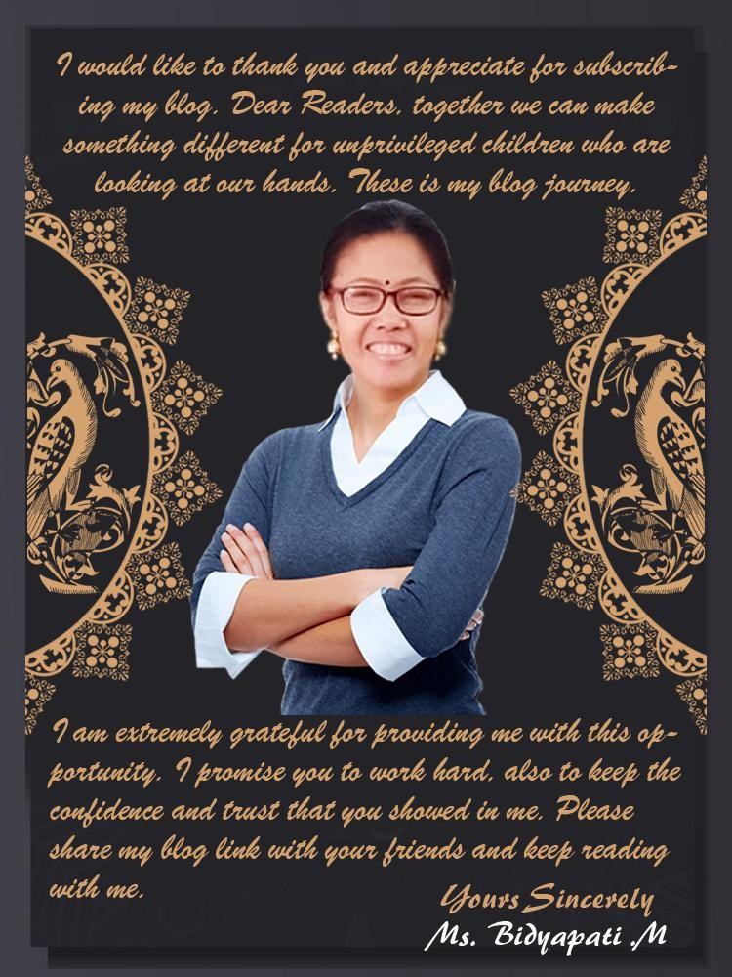

[CLICK HERE, TO GET MORE INFORMATION](https://bidyapatibedstudy.wordpress.com/journey-of-together/)



