**Report**

Anti-Drug Awareness Programme

Date: 22/08/2023

Organized by: Mundeshwari College for Teacher Education.

An Anti-Drug Awareness Programme was organized at our College to educate students about the dangers of drug abuse and to promote a drug-free lifestyle. The event was attended by trainees, faculty members, and principal aimed to highlight the harmful effects of drug addiction on individuals and society.

The programme began with a welcome speech by the principal, who emphasized the importance of staying informed about the consequences of drug use and the role of youth in building a healthy, drug-free community. An interactive session followed, where students were encouraged to ask questions and share their thoughts. The trainees were made different anti-drug related posters. The programme concluded with a pledge-taking ceremony, where all attendees vowed to stay away from drugs and work towards maintaining a drug-free campus environment.

The Anti-Drug Awareness Programme was a great success, with active participation from students and faculty members. It effectively conveyed the message about the dangers of drug abuse and the importance of making healthy life choices. The event helped raise awareness and equipped students with the knowledge to avoid drug-related issues and promote a safe, supportive environment in the college.

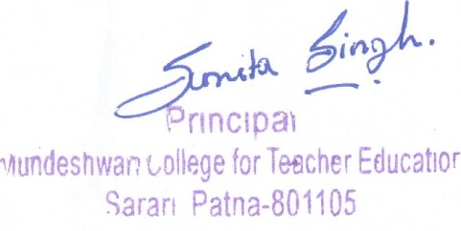

**Photographs of the events**

